Activity 4

B25CE1205 SARVESH MANDE CE3 C

Research

A database is an electronically stored, systematic collection of data. It can contain any type of data, including words, numbers, images, videos, and files. You can use software called a database management system (DBMS) to store, retrieve, and edit data. In computer systems, the word database can also refer to any DBMS, to the database system, or to an application associated with the database.
Databases support the internal operations of companies and store interactions with customers and suppliers. They also hold administrative information and more specialized data, such as engineering or economic models.

Organizations use different types of databases to manage different types of data and support different applications. Some of the most common types of databases include:
- Navigational databases
- Relational databases
- Nonrelational databases or NoSQL databases
- Object-oriented databases
- Vector databases
- Cloud databases

- Banking and Finance
- The banking and financial sector relies heavily on databases to maintain customer accounts, transaction records, loan details, and credit information. These systems must prioritize security and accuracy while also supporting fraud detection and real-time risk analysis.
- Supply Chain Management
Supply chain database applications track products from manufacturing todelivery, integrating data from multiple sources: warehouse management systems, transportation tracking, and vendor databases. They enable features like automated reordering, demand forecasting, and real-time inventory optimization across multiple locations.

- Education Sector:
- In this the databases store student records, course schedules, grades, and learning materials. They also help track academic progress and support online learning environments with large volumes of educational content.

- Healthcare industry
- In this the databases manage electronic health records, patient appointments, diagnostic information, and treatment histories. They also store medical images and support systems that ensure timely and accurate access to critical patient data.

- Telecommunication
- In this the databases handle call records, billing information, customer plans, and network traffic data. They support reliable communication services and efficient management of large subscriber bases.

Analysis:

- Input:
Allows the user to enter details for up to ten cinema bookings. For each booking, the program collects the customer’s name, movie name, show time, number of seats, total ticket price, and the show date. These details are stored in a structure called cinema, which helps keep all related information together in a single unit. The program also validates the number of bookings at the start to ensure it stays within the defined limit of ten entries.
- Process:
Involves sorting the entered booking records based on their ticket price. The program utilizes a bubble sort technique, which uses nested loops to compare the ticket prices of adjacent bookings. If a booking has a higher price than the one following it, their positions are swapped using a temporary variable. This process repeats until all bookings are arranged in ascending order, from the lowest ticket price to the highest.
- Output:
Displays all the booking details after sorting in a professional, tabular format. The program uses fixed-width alignment to print the customer name, movie title, show time, seats, price, and date in perfectly straight columns. By presenting the bookings sorted by price, the output provides a clear financial overview, allowing the user to easily identify the most affordable and most expensive bookings at a glance.

Ideation:
To create a simple digital tool for managing cinema tickets. This program replaces messy paper records by storing customer and movie details in a structured format. By automatically sorting bookings by price and displaying them in a clean table, it makes tracking ticket sales easy, organized, and efficient for the user.

Algorithm
- 1.Start the program.
- 2.Ask the user how many cinema bookings to enter.
- 3.For each booking:
• Read customer name
• Read movie name
• Read show time
• Read number of seats
• Read ticket price
• Read show date
• Store all details in the structure
- 4.Sort all bookings in ascending order based on ticket price.
- 5.Display all the sorted bookings in a neatly formatted table.
- 6.End the program.

Build:
#include <stdio.h>
#include <string.h>

struct Cinema {
char customer_name[20];
char movie_name[20];
char show_time[15];
int seats;
int ticket_price;
int date; // DDMMYYYY format
};

int main() {
struct Cinema booking[10], temp;
int n;

printf("Enter number of bookings (max 10): ");
if (scanf("%d", &n) != 1 || n < 1 || n > 10) {
printf("Invalid number of bookings. Exiting.\n");
return 1;
}

for (int i = 0; i < n; i++) {
printf("\n--- ENTER DETAILS FOR BOOKING %d ---\n", i + 1);

printf("ENTER CUSTOMER NAME: ");
scanf("%s", booking[i].customer_name);

printf("ENTER MOVIE NAME: ");
scanf("%s", booking[i].movie_name);

printf("ENTER SHOW TIME: ");
scanf("%s", booking[i].show_time);

printf("ENTER NUMBER OF SEATS: ");
scanf("%d", &booking[i].seats);

printf("ENTER TOTAL TICKET PRICE: ");
scanf("%d", &booking[i].ticket_price);

printf("ENTER SHOW DATE (DDMMYYYY): ");
scanf("%d", &booking[i].date);
}

for (int i = 0; i < n - 1; i++) {
for (int j = 0; j < n - i - 1; j++) {
if (booking[j].ticket_price > booking[j + 1].ticket_price) {
temp = booking[j];
booking[j] = booking[j + 1];
booking[j + 1] = temp;
}
}
}

printf("\n\n================ CINEMA BOOKING DETAILS ================\n");

// Header with alignment
printf("%-15s %-15s %-12s %-8s %-10s %-12s\n",
"NAME", "MOVIE", "TIME", "SEATS", "PRICE", "DATE");

printf("--------------------------------------------------------------------------\n");

// Table Rows aligned
for (int i = 0; i < n; i++) {
printf("%-15s %-15s %-12s %-8d %-10d %-12d\n",
booking[i].customer_name,
booking[i].movie_name,
booking[i].show_time,
booking[i].seats,
booking[i].ticket_price,
booking[i].date);
}

printf("====================================================================");
return 0;
}

test:
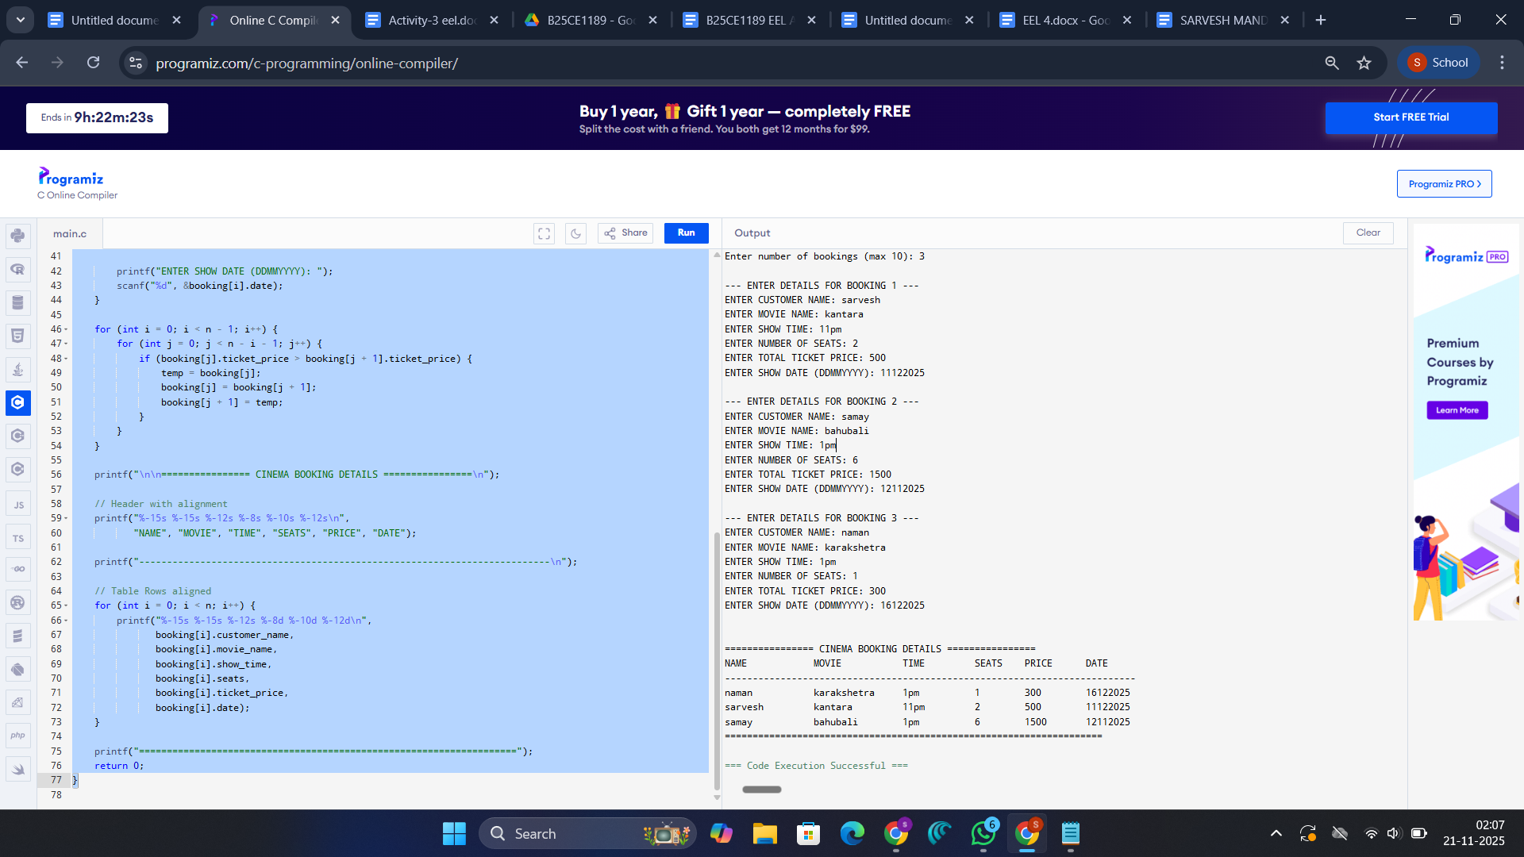

implementation:https://github.com/sarvesh00719/cinema-database-manager.git

